  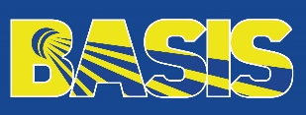 | Application Form – World Academy of Sport Courses  National Administrators’ Course including Strategic Planning Day or Level 1 Event Management Course  Brežice, Slovenia  (25th & 26th November 2021) |  |  |   
Organization Details  Organization:  Contact person:  Phone:  Email:  Personal experience  Please provide a statement detailing your education, current role within your federation, any other relevant experience and how you can contribute to the learning environment on the course.  (250 words maximum) |  |  | Personal Details - Candidate  Choose an item.  Course  Name and surname:  Date of Birth:  Gender:  Phone:  Email:  Position in the  organization:  Expected learning outcomes  Please provide a statement detailing what you expect to get out of the programme and how your federation intends to use the outcomes to maximise the benefits of attending.  (250 words maximum)
The deadline to send the application form to Badminton Europe is on Wednesday, 13th October 2021.
Please send the application form to Andreja Turk – andreja.turk@badmintoneurope.com

